**Qlikview Representing Top Tracks 2017**

Nuraan Khan

what I was interested in is finding out how a song is chosen to be on a "Top list" to start my quest of data analysis I wanted to know if there were any artists who had more than one song of theirs on the top tracks list. Using Qlikview software I found that artists: Ed Sheeran and The Chainsmokers had each 4 songs of their album on the list.

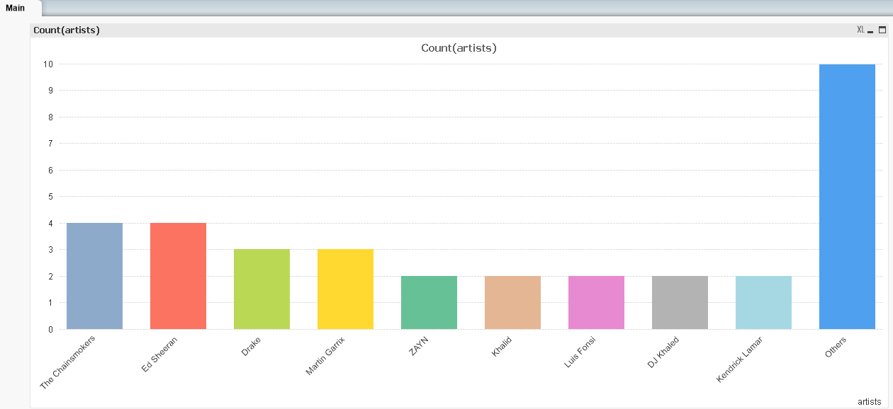

"what made their songs more popular than others?" was it crazy fandom for the artist or was it something/ some song feature that the audience from all

over. Next, I grouped the different song features: 1) Acousticness, Instrumentalness and Speechiness & 2) Danceablility, Tempo and Energy

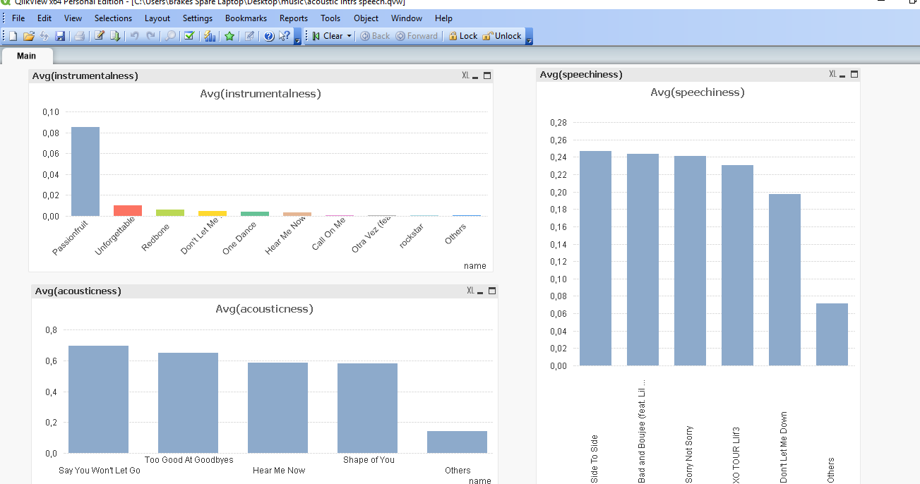

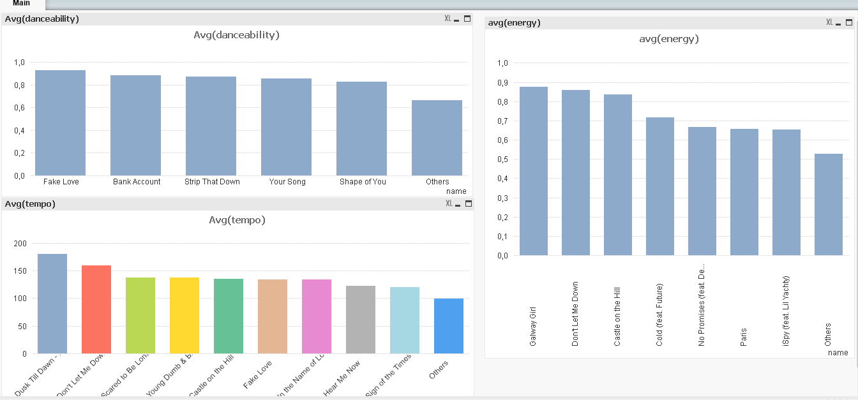

there was also Valence that I wanted to check out for each song. Valence is the positive message conveyed by a track. The higher the valence, the more joy, happy the songs message is and vice versa.

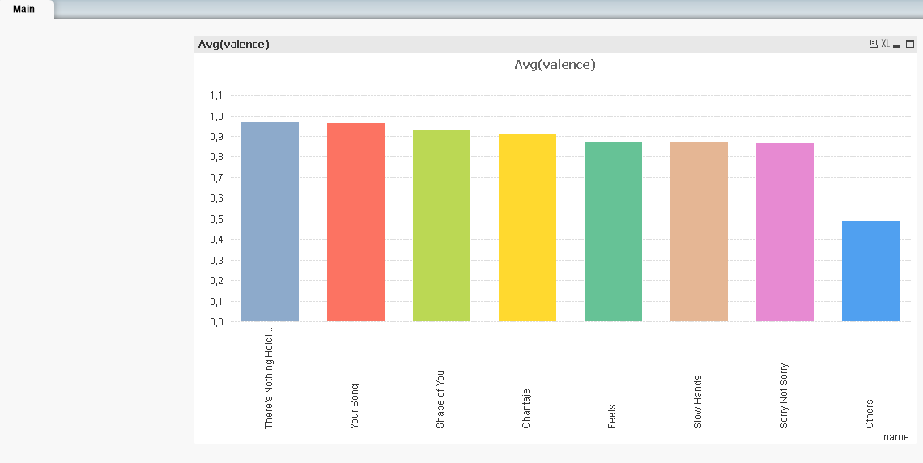

checking group 1 song features, I looked for the artists songs (Ed Sheeran and The Chainsmokers), I was looking if their songs would appear with high levels in those song features.

in group 2 song features: Danceability, energy and tempo. 2 of Ed Sheeran and 2 of the Chainsmokers songs were in the top 10 for energy levels.

from this I concluded that most songs that make the list for top tracks is based on the energy the track gives. Energetic songs are fast paced and induces dancing. dancing is something everyone enjoys (even those with 2 left feet or stiff as wood). Energetic music literally "energizes" people and keeps them going when they’re tired or need a pick me up.